Three Observable Trends:

1) Whether viewed as overall data or as a regression based on the Northern or Southern Hemisphere – there is clearly a correlation between proximity to the equator and temperature.

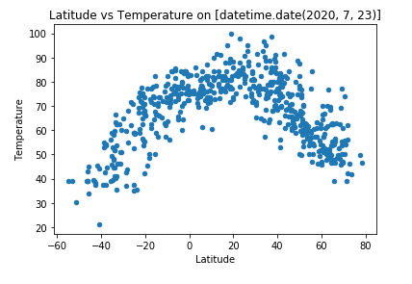

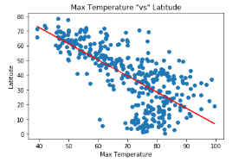

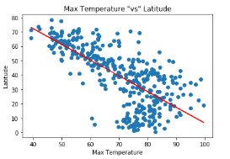

2) There is very little correlation between humidity/ cloudiness and proximity to the equator. I would be more inclined to look for a correlation between humidity and cloudiness! Logically, this lack of evidence can make sense as we are just looking as a single weather data point – perhaps if we trended overtime there would be more of an argument that it is more humid or more clouds near the equator.

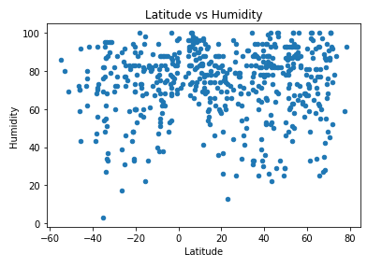

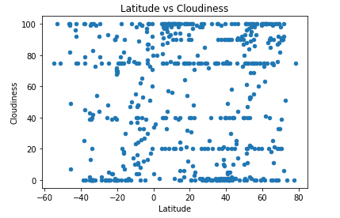

3) Windspeed was another variable that mapped separately from Latitude. I would expect this to be a variable more dependent on the current weather and geography (coastal) than proximity to the equator, so this makes sense. The high windspeeds noted are likely a storm (greater than 30 mph).

From this I can gather expected windspeeds for all locations should most often fall between 0 and 15mph.

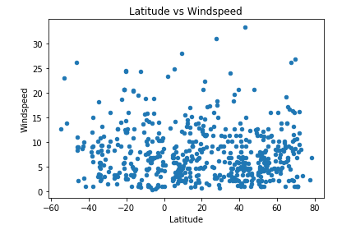

4) More of a personal observation – but I was surprised to see my “Ideal Cities” are much wider spread than expected. This may be because my dataframe is primarily looking at summer temps (with today being in July)– but a few of my “ideal cities” were farther north than I would have expected – including the US and Canada!

